PUBLIC HEALTH AWARENESS

1. Introduction

In this work, we aim to analyze survey data to gain insights into the spread of the virus and associated mortality. Our study uses IBM Cognos and focuses on comparing the standard deviation and accuracy of the data. Our findings will help us understand trends, changes and potential relationships.

2. Data creation

The survey dataset was uploaded to IBM Cognos, and data cleaning was performed to check for missing values or outliers. The dataset includes information on cases and deaths.

3. Data visualization
- Comparison of mean values

Bar charts were generated to compare the number of associated cases and associated deaths in different groups (e.g. region, etc.).

- Standard deviation comparison

Box plots were used to visualize the distribution of cases and deaths, highlighting medians, quartiles, and potential extremes.

- Long-term trends

The graph was used to track trends in incidence and mortality over time, allowing us to track the evolution of the epidemic.

- Communication analysis

Scatter plots were constructed to examine possible relationships between population size and mortality. Correlation coefficients were calculated to quantify these relationships.

4. Research and analysis Trends

We observed significant variability in COVID-19 cases and deaths across regions.These changes may be due to factors such as demographics, health care, and public health policies. Correlation: Our study shows a strong positive association between population size and associated mortality. As cases rise, so do deaths. This relationship underscores the importance of timely preventive and therapeutic interventions.

5. Conclusions

The project data analysis using IBM Cognos provided valuable insights into the COVID-19 epidemic. Trends and changes were identified, providing potential areas for targeted intervention. Correlational analysis emphasizes the importance of proactive measures to reduce the spread of the virus and save lives.

1 | P a g e

PROJECT REPORT: PUBLIC AWARENESS ANALYSIS

DATA VISUALIZATION AND ANALYSIS

- Number of people attend mental health interview

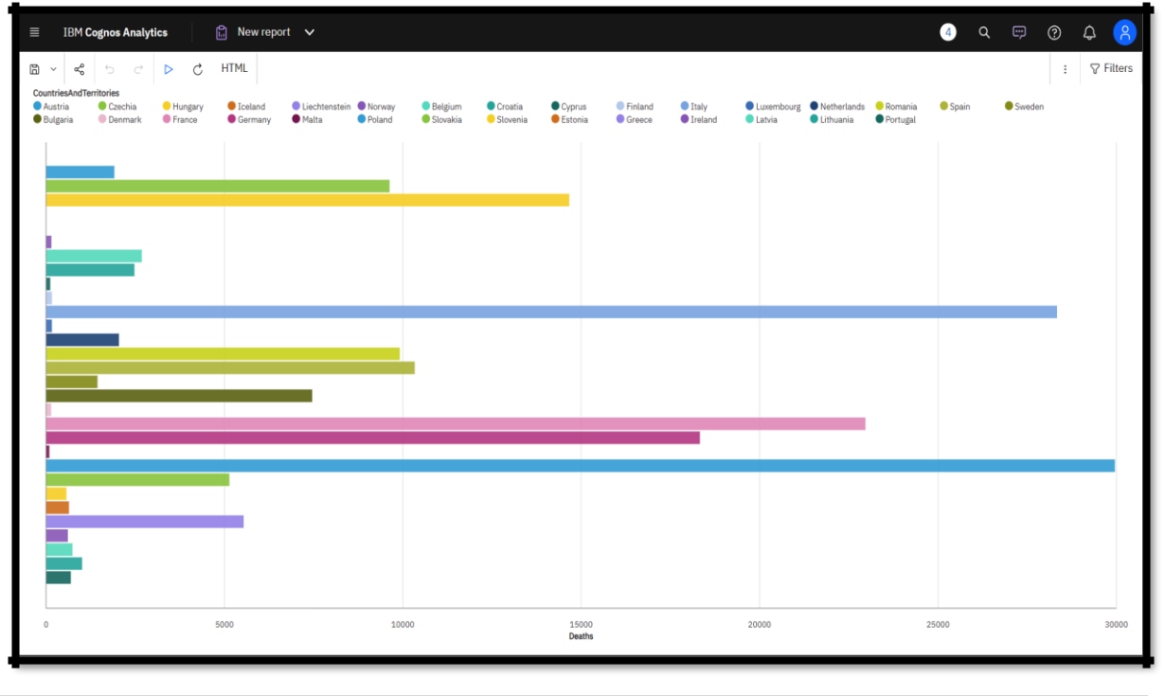

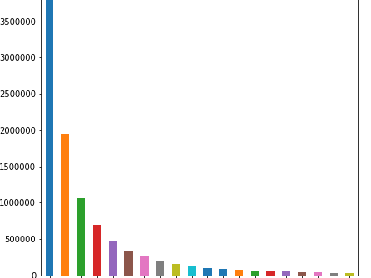

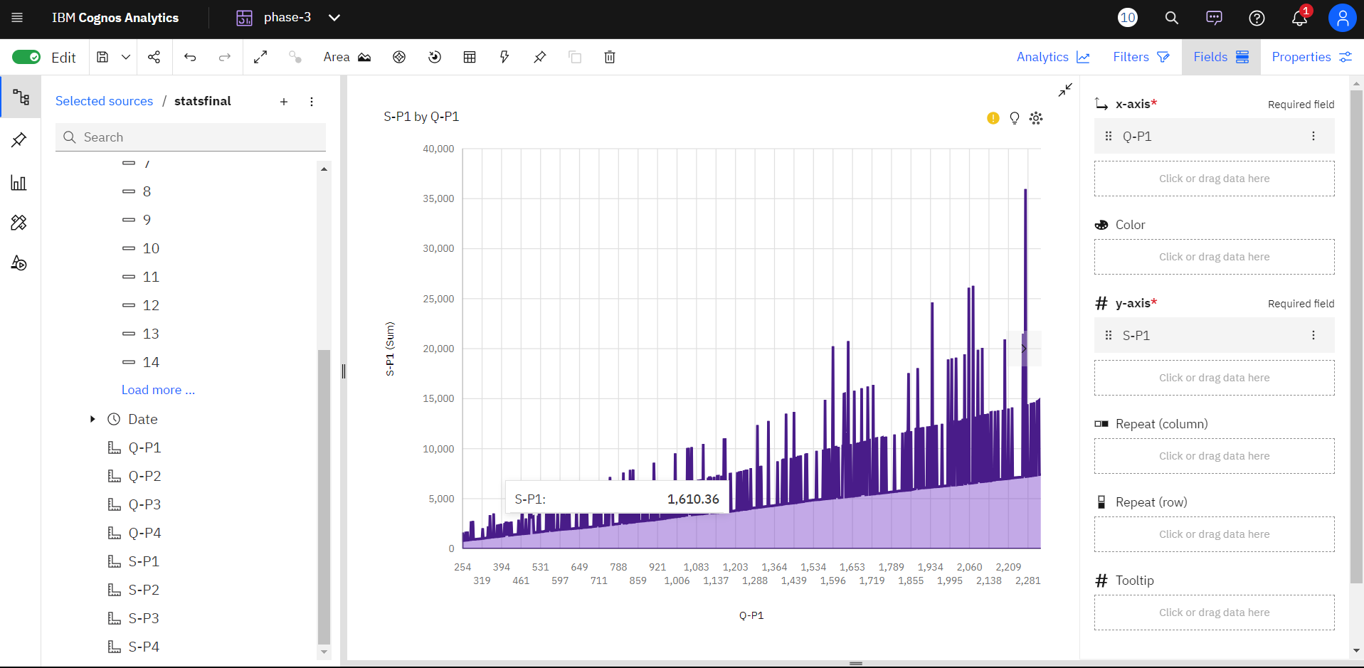

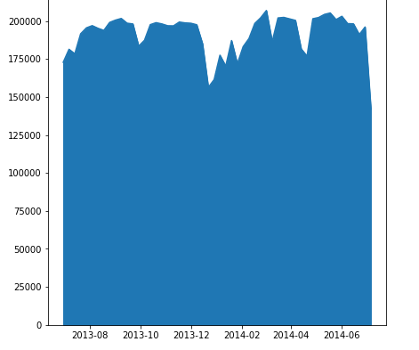

2 | P a g e

PROJECT REPORT: PUBLIC AWARENESS

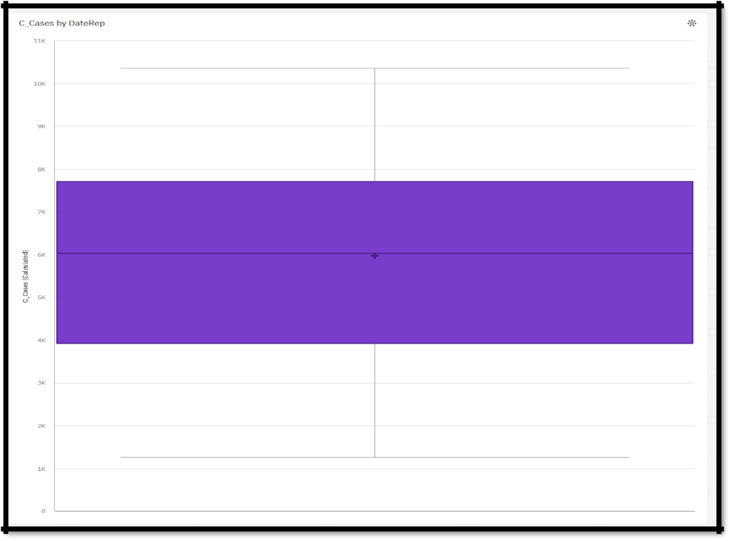

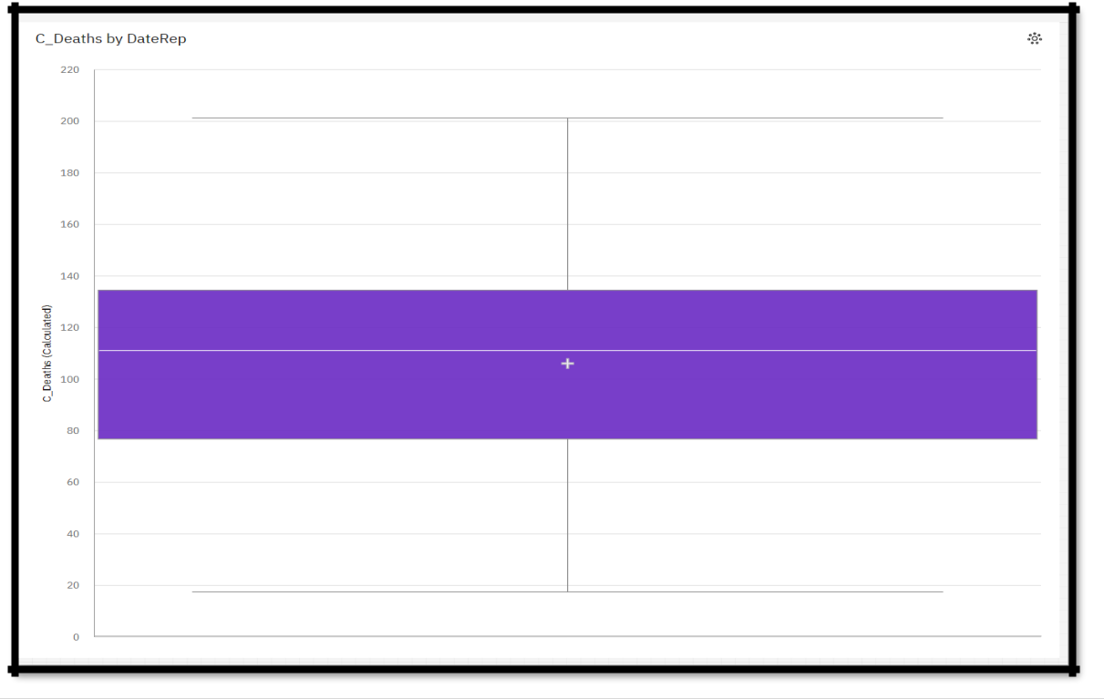

3 | P a g e
PROJECT REPORT: PUBLIC AWARENESS

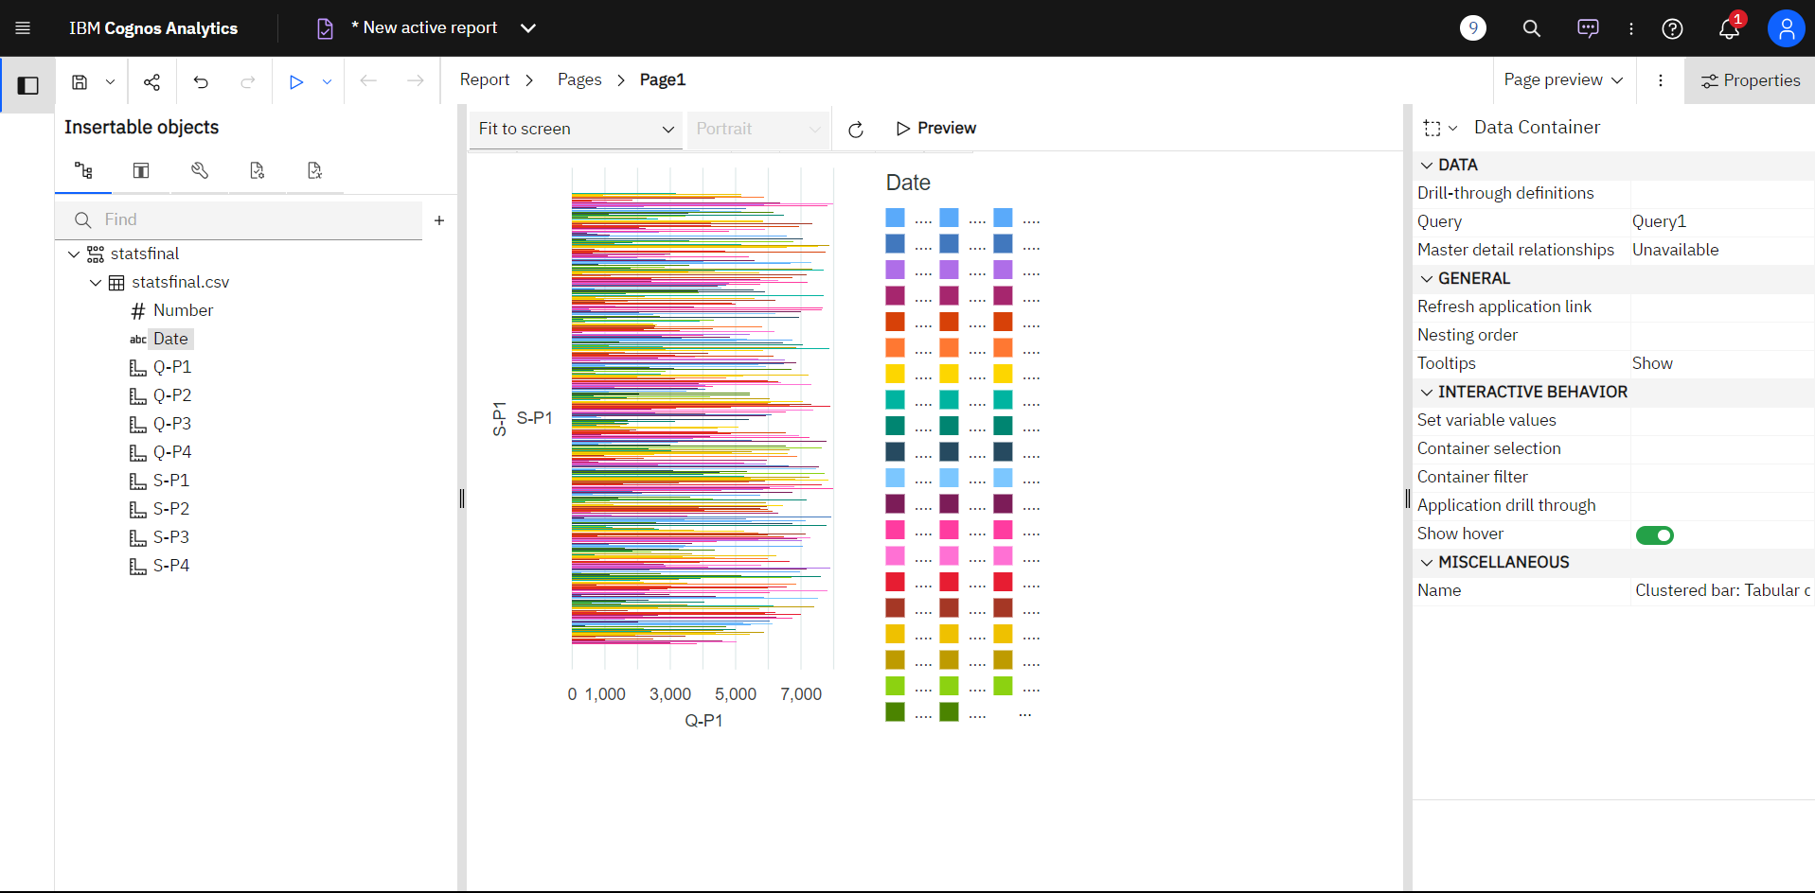

4 | P a g e

